Reflection

I learned things about a computer's interior parts during the PC assembly session that I had never known before. The PC assembly activities is very important for me since I am a computer science student and it is important for me to know about he computer part. Other than that It also help me to know on how to assemble and dissemble the PC from scratch. It show the important of each component in PC to ensure that the PC can work properly.

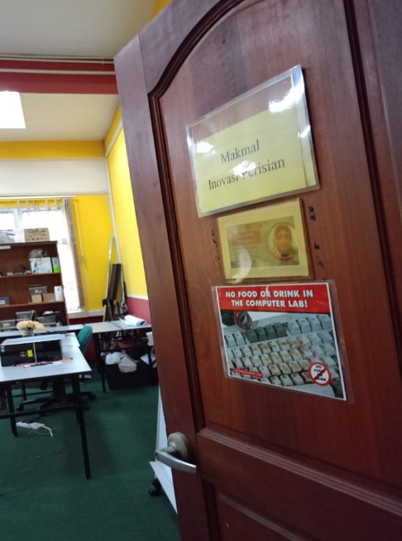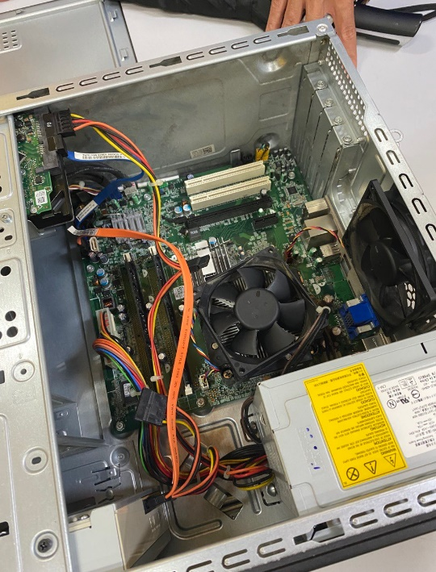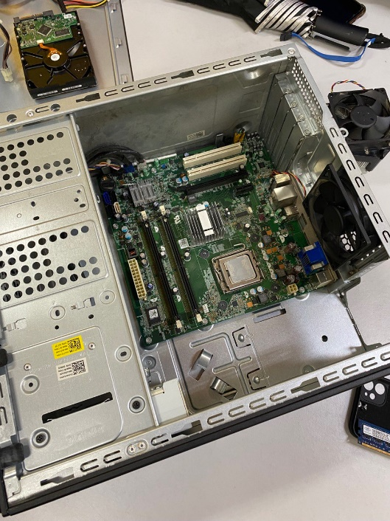I will always cherish this opportunity, which felt like a once-in-a-lifetime chance. Thanks to Dr. Aryati and the technicians, I also learnt about the role of each CPU component and how it affects the system as a whole.